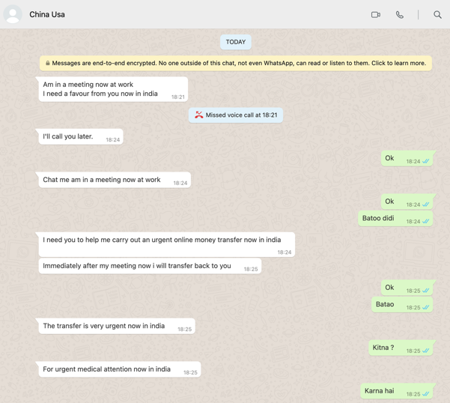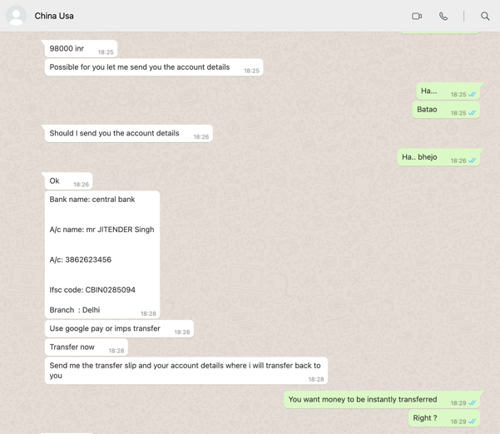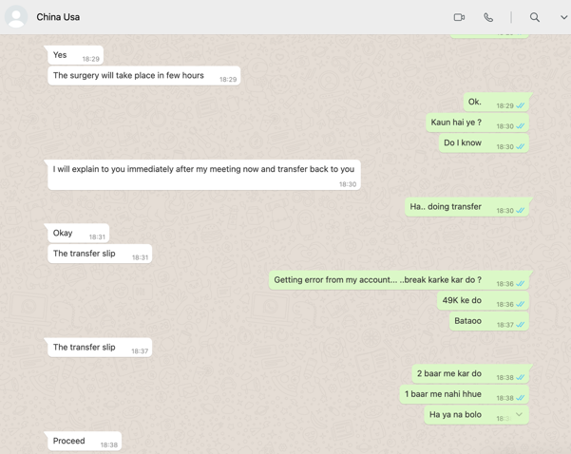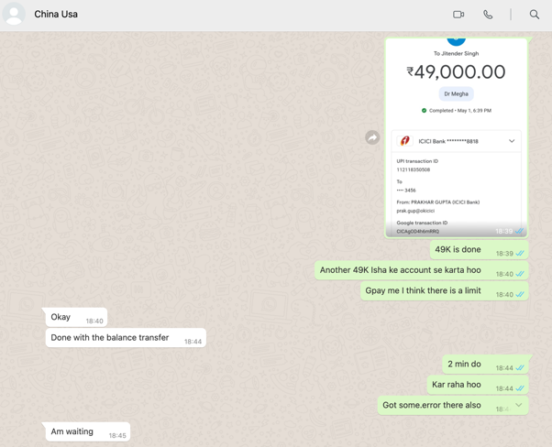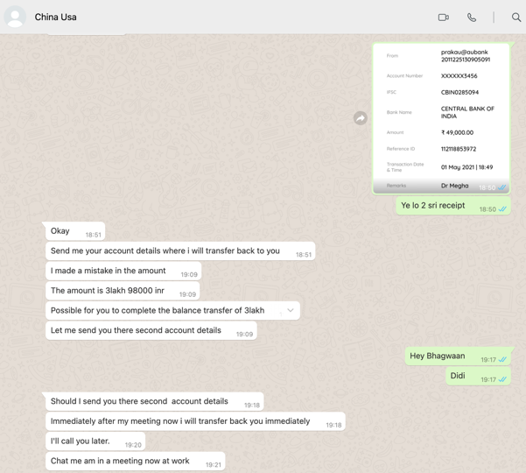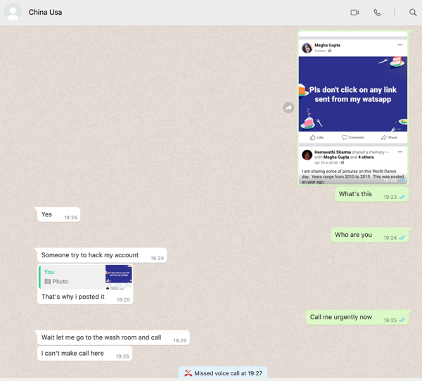

[18:21, 5/1/2021] China Usa: Am in a meeting now at work

I need a favour from you now in india

[18:24, 5/1/2021] China Usa: I'll call you later.

[18:24, 5/1/2021] Prakhar Gupta: Ok

[18:24, 5/1/2021] China Usa: Chat me am in a meeting now at work

[18:24, 5/1/2021] Prakhar Gupta: Ok

[18:24, 5/1/2021] Prakhar Gupta: Batoo didi

[18:24, 5/1/2021] China Usa: I need you to help me carry out an urgent online money transfer now in india

[18:25, 5/1/2021] China Usa: Immediately after my meeting now i will transfer back to you

[18:25, 5/1/2021] Prakhar Gupta: Ok

[18:25, 5/1/2021] Prakhar Gupta: Batao

[18:25, 5/1/2021] China Usa: The transfer is very urgent now in india

[18:25, 5/1/2021] Prakhar Gupta: Kitna ?

[18:25, 5/1/2021] China Usa: For urgent medical attention now in india

[18:25, 5/1/2021] Prakhar Gupta: Karna hai

[18:25, 5/1/2021] China Usa: 98000 inr

[18:25, 5/1/2021] China Usa: Possible for you let me send you the account details

[18:25, 5/1/2021] Prakhar Gupta: Ha...

[18:25, 5/1/2021] Prakhar Gupta: Batao

[18:26, 5/1/2021] China Usa: Should I send you the account details

[18:26, 5/1/2021] Prakhar Gupta: Ha.. bhejo

[18:26, 5/1/2021] China Usa: Ok

[18:28, 5/1/2021] China Usa: Bank name: central bank

A/c name: mr JITENDER Singh

A/c: 3862623456

Ifsc code: CBIN0285094

Branch : Delhi

[18:28, 5/1/2021] China Usa: Use google pay or imps transfer

[18:28, 5/1/2021] China Usa: Transfer now

[18:28, 5/1/2021] China Usa: Send me the transfer slip and your account details where i will transfer back to you

[18:29, 5/1/2021] Prakhar Gupta: You want money to be instantly transferred

[18:29, 5/1/2021] Prakhar Gupta: Right ?

[18:29, 5/1/2021] China Usa: Yes

[18:29, 5/1/2021] China Usa: The surgery will take place in few hours

[18:29, 5/1/2021] Prakhar Gupta: Ok.

[18:30, 5/1/2021] Prakhar Gupta: Kaun hai ye ?

[18:30, 5/1/2021] Prakhar Gupta: Do I know

[18:30, 5/1/2021] China Usa: I will explain to you immediately after my meeting now and transfer back to you

[18:30, 5/1/2021] Prakhar Gupta: Ha.. doing transfer

[18:31, 5/1/2021] China Usa: Okay

[18:31, 5/1/2021] China Usa: The transfer slip

[18:36, 5/1/2021] Prakhar Gupta: Getting error from my account... ..break karke kar do ?

[18:36, 5/1/2021] Prakhar Gupta: 49K ke do

[18:37, 5/1/2021] Prakhar Gupta: Bataoo

[18:37, 5/1/2021] China Usa: The transfer slip

[18:38, 5/1/2021] Prakhar Gupta: 2 baar me kar do

[18:38, 5/1/2021] Prakhar Gupta: 1 baar me nahi hhue

[18:38, 5/1/2021] Prakhar Gupta: Ha ya na bolo

[18:38, 5/1/2021] China Usa: Proceed

[18:39, 5/1/2021] Prakhar Gupta: 49K is done

[18:40, 5/1/2021] Prakhar Gupta: Another 49K Isha ke account se karta hoo

[18:40, 5/1/2021] Prakhar Gupta: Gpay me I think there is a limit

[18:40, 5/1/2021] China Usa: Okay

[18:44, 5/1/2021] China Usa: Done with the balance transfer

[18:44, 5/1/2021] Prakhar Gupta: 2 min do

[18:44, 5/1/2021] Prakhar Gupta: Kar raha hoo

[18:44, 5/1/2021] Prakhar Gupta: Got some.error there also

[18:45, 5/1/2021] China Usa: Am waiting

[18:50, 5/1/2021] Prakhar Gupta: Ye lo 2 sri receipt

[18:51, 5/1/2021] China Usa: Okay

[18:51, 5/1/2021] China Usa: Send me your account details where i will transfer back to you

[19:09, 5/1/2021] China Usa: I made a mistake in the amount

[19:09, 5/1/2021] China Usa: The amount is 3lakh 98000 inr

[19:09, 5/1/2021] China Usa: Possible for you to complete the balance transfer of 3lakh

[19:09, 5/1/2021] China Usa: Let me send you there second account details

[19:17, 5/1/2021] Prakhar Gupta: Hey Bhagwaan

[19:17, 5/1/2021] Prakhar Gupta: Didi

[19:18, 5/1/2021] China Usa: Should I send you there second account details

[19:18, 5/1/2021] China Usa: Immediately after my meeting now i will transfer back you immediately

[19:20, 5/1/2021] China Usa: I'll call you later.

[19:21, 5/1/2021] China Usa: Chat me am in a meeting now at work

[19:23, 5/1/2021] Prakhar Gupta: What's this

[19:24, 5/1/2021] China Usa: Yes

[19:24, 5/1/2021] Prakhar Gupta: Who are you

[19:24, 5/1/2021] China Usa: Someone try to hack my account

[19:25, 5/1/2021] China Usa: That's why i posted it

[19:25, 5/1/2021] Prakhar Gupta: Call me urgently now

[19:26, 5/1/2021] China Usa: Wait let me go to the wash room and call

[19:26, 5/1/2021] China Usa: I can't make call here

[19:28, 5/1/2021] China Usa: Network is bad here i will call you immediately after my meeting Okay

[19:30, 5/1/2021] Prakhar Gupta: Who are you